Practical – 6
Write a program to implement the Naïve Bayesian classifier for a sample training data set stored as a .CSV file. Compute the accuracy of the classifier, considering few test data sets.
- What is Naïve Bayes?
Naïve Bayes is a supervised machine learning algorithm used for classification problems.
It is based on Bayes Theorem, which calculates the probability of a class based on prior knowledge of conditions related to that class.
The algorithm assumes that the features are independent of each other, which is why it is called “Naïve”.
Naïve Bayes is widely used for text classification, spam filtering, and medical diagnosis.
- What is Bayes Theorem?
Bayes Theorem describes the probability of an event based on prior knowledge.
Formula
P(AB)=P(BA)×P(A)P(B)P(A|B) = \frac{P(B|A) \times P(A)}{P(B)}P(AB)=P(B)P(BA)×P(A) Where:
  - P(A|B) = Posterior Probability
  - P(B|A) = Likelihood
  - P(A) = Prior Probability
  - P(B) = Evidence
In machine learning, this formula helps to predict the class label of new data.
- Core Concept of Naïve Bayes
Naïve Bayes calculates the probability of each class and chooses the class with the highest probability.
Posterior Probability
P(ClassFeatures)=P(FeaturesClass)×P(Class)P(Features)P(Class|Features) =
\frac{P(Features|Class) \times
P(Class)}{P(Features)}P(ClassFeatures)=P(Features)P(FeaturesClass)×P(Class) Where:
  - P(Class) = Prior probability of the class
  - P(Features|Class) = Probability of features given the class
  - P(Class|Features) = Probability of class given features
The classifier predicts the class that has the maximum posterior probability.
- Types of Naïve Bayes
There are mainly three types of Naïve Bayes classifiers:
- Gaussian Naïve Bayes
Used when the features follow a normal distribution.
- Multinomial Naïve Bayes
Used mainly for text classification problems such as spam detection.
- Bernoulli Naïve Bayes
Used when features are binary (0 or 1).
5. Steps for Naïve Bayes Implementation
I.: Import Libraries
import kagglehub
path = kagglehub.dataset_download("amineipad/titanic-dataset")
print("Path to dataset files:", path)

II. : Load Dataset from CSV File
import numpy as np
import pandas as pd
from sklearn.model_selection import train_test_split from sklearn.naive_bayes import GaussianNB from sklearn.metrics import accuracy_score from sklearn.preprocessing import LabelEncoder
data = pd.read_csv(path + "/train.csv") print("First 5 rows:") print(data.head())
OUTPUT:
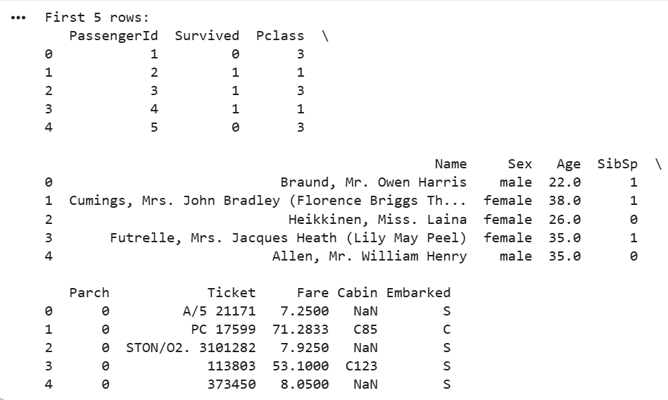

III.: Separate Features and Target data data[['Survived','Pclass','Sex','Age','SibSp','Parch','Fare','Embarked']]
IV. Handle Missing Values
data['Age'].fillna(data['Age'].mean(), inplace=True) data['Embarked'].fillna(data['Embarked'].mode()[0], inplace=True)
V. Convert Categorical Data to Numeric le = LabelEncoder()
data['Sex'] = le.fit_transform(data['Sex'])
data['Embarked'] = le.fit_transform(data['Embarked'])
VI.: Split Training and Testing Data
X = data.drop('Survived', axis=1)
y = data['Survived']
VII.: Train Naïve Bayes Model
model = GaussianNB() model.fit(X_train, y_train)
VIII.: Make Predictions
y_pred=model.predict(X_test) print("Predicted values:") print(y_pred)
OUTPUT:
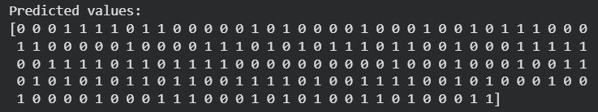
IX.: Calculate Accuracy accuracy = accuracy_score(y_test, y_pred) print("Accuracy of Naive Bayes Classifier:", accuracy * 100)
OUTPUT:
X.Test with new sample sample = [[3,1,25,0,0,7.25,2]] prediction = model.predict(sample) print("Prediction:", prediction)
OUTPUT:

- Advantages of Naïve Bayes
  - Simple and easy to implement
  - Works well with large datasets
  - Requires less training data
  - Fast prediction speed
  - Performs well in text classification problems
- Limitations of Naïve Bayes
  - Assumes features are independent
  - Not suitable when features are highly correlated
  - Zero probability problem may occur if a category is missing in training data
- Applications of Naïve Bayes
  - Spam email detection
  - Sentiment analysis
  - Document classification
  - Medical diagnosis
  - Recommendation systems
Conclusion
Naïve Bayes is a simple yet powerful classification algorithm based on Bayes theorem. It assumes independence between features and calculates probabilities to classify new data. Due to its simplicity and efficiency, it is widely used in machine learning applications such as spam filtering, text classification, and medical prediction.

